Pre-K Supply List
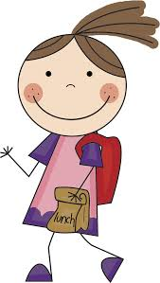
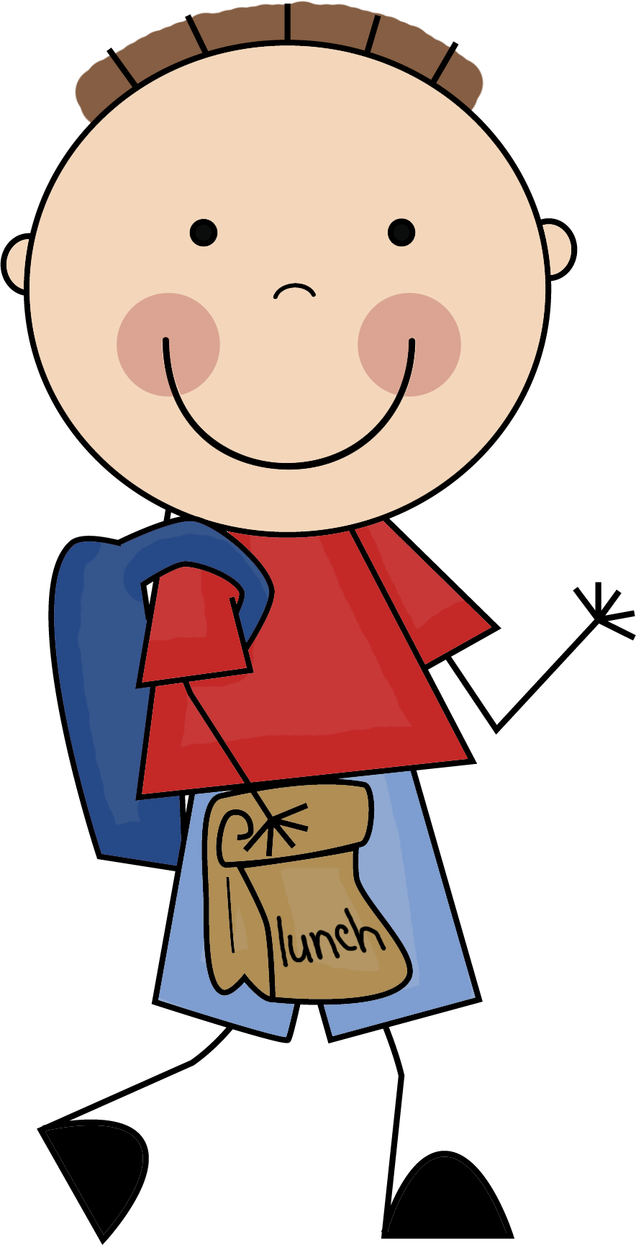

3 Large bags of students’ favorite cereal
1 Large container of Goldfish, Granola
Bars or Popcorn
1 Box Crayola Markers
2 Boxes of Kleenex
Gallon or Quart size Ziploc bags
1 Art apron or an old t-shirt to stay in the classroom
1 Pair of gym shoes to stay in the classroom

If money is a problem do not feel obligated to purchase anything. Other parents may be able to supplement more. We will see you in the fall!
Mrs. Tiedemann

Pre-K Supply List

3 Large bags of students’ favorite cereal
1 Large container of Goldfish, Granola
Bars or Popcorn
1 Box Crayola Markers
2 Boxes of Kleenex
Gallon or Quart size Ziploc bags
1 Art apron or an old t-shirt to stay in the classroom
1 Pair of gym shoes to stay in the classroom

If money is a problem do not feel obligated to purchase anything. Other parents may be able to supplement more. We will see you in the fall!
Mrs. Tiedemann

