General Supply List for Sterling Elementary
Primary (Grades K-3)

- 2 dozen yellow, Ticonderoga #2 pencils
- 1 box Crayola 10-pack broad line basic markers
- 1 box 16 -24 Crayola Crayons
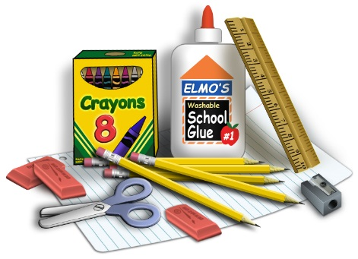
- 6-10 small glue sticks or 3 large glue sticks
- 3 pink erasers
- 1 box Ziploc sandwich bags
- 2 boxes of Kleenex
- 2 containers of baby wipes
- 1 pair of headphones/ earbuds to stay at school
- *Gym/Indoor shoes with non-marking soles to be left at school. Your child should be able to put these on independently.
- *Back Pack (w/o wheels)
- *1 pair child school scissors

- Bike helmet, if student may ever ride their bike to school

Optional Donations:
- 1 container disinfecting wipes (Clorox or other)
- Extra Kleenex
- Extra Glue Sticks
- Quart or Gallon sized Ziploc Bags

*ONLY items marked with asterisks (scissors, gym shoes and backpack) need labeled with your child’s name, as your child will be responsible for those items. The remaining items on our supply lists will be used for whole class projects and do not need to be labeled as the entire class community shares those supplies as needed.

